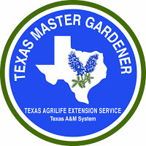

2018 Green Thumb Programs
Highland Lakes Master Gardener Association

12:00 to 1:00 pm

Kingsland Library  Lakeshore Library
125 W. Polk, Kingsland 7346 Hwy 261, Buchanan Dam

Jan 10 Vegetables Year Round Kelly Tarla
Burnet County Extension Agent,

Feb 7 Rain Water Collections Wade Hibler
Burnet County Extension (Retired)

March 7 Composting Made Easy Willard Horn
Master Gardener

April 11 Trees of Texas and Landscaping Kelly Tarla
 Lakeshore Library Burnet County Extension Agent

May 10 What’s ”Bugging” Y’all Now? (Entomology) Susan Rowly
Master Gardener

June 13 Multiplying Succulents by Propagation Amy Parke
Master Gardener

July 27 Water Conservation and Home Landscaping Wade Hibler
 Lakeshore Library Burnet County Extension (Retired)

Aug 8 Cancelled

Sept 12 ART AND ARCHITECTURE INSPIRED BY PLANTS Allison Bennett
Master Gardener

Oct 10 A CACTUS PRIMER: Care and Handling of Six Species of Texas Cactus
Alice Liles, Specialist

 As specified above, two programs are at Lakeshore Library.

